WDCL AGM Presentation of Trophies
Stewart Fishburn, Halesowen receives the Division 1 Championship Trophy
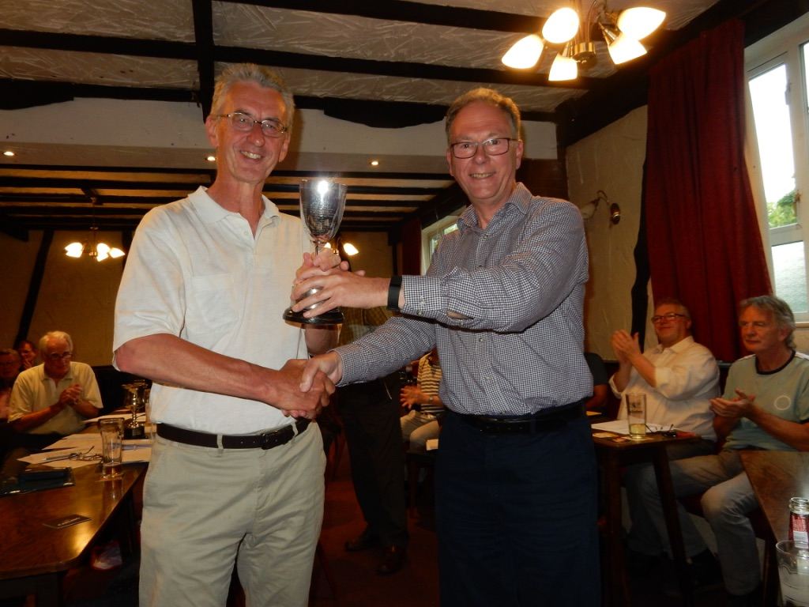

David Short, Lichfield receives the Pittaway Cup
