WDCL AGM May 19th 2016
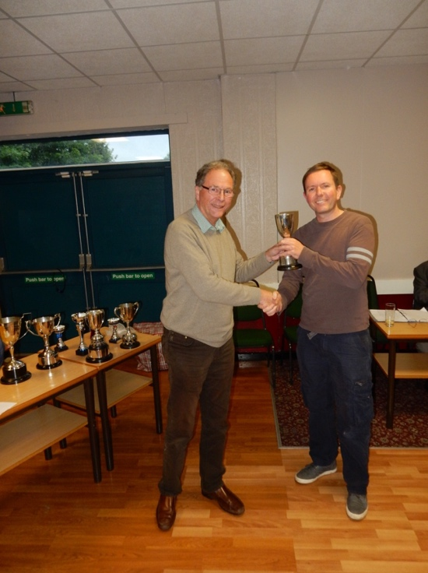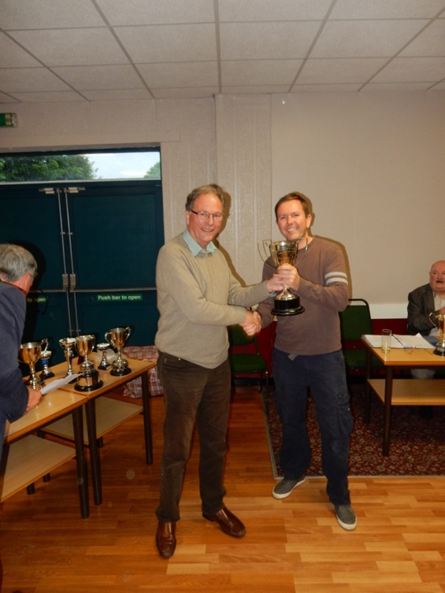
Gary Haime Captain of League and Cup double winners Lichfield receives the League Champions Cup (left) and Pittaway Trophy (right) from David Fone WDCL President

News from the AGM
The vacancy for a league secretary was resolved by Mike Groombridge agreeing to stay on for one more year, when David Fone the current President will finish his term of office and
put himself forward for nomination as secretary to next years AGM. Other candidates are still welcome, we need broader support from more the members of the WDCL community to keep the league running smoothly.

