Wolverhampton and District Chess League

Minutes of the AGM held on May 24th 2018 at Wolverhampton Chess Club @ 7h30pm

- Apologies: Mike Groombridge, Richard Thompson, John Fahy, Andrew McCumiskey, Phil Staley, John Wrench, Jonathan Pincher.
Attending: M Carr Rugeley (President), D Fone Lichfield (Secretary), D Scriven (records Secretary) and P Sharratt (Treasurer) both Stourbridge, D Perks Mercia (Tournament Secretary and Auditor), D Short Lichfield (Publicity Secretary), C Hiley Rugeley (Lead for Safeguarding), D Blower and A Davies Brewood, P Thomas and T Pountney Kidderminster, D Anderton Walsall Kipping, M Oakes and F Wood Wolverhampton, M Phipps and M Biddle Boldmere, S Wilcox Rushall, J Southcote Halesowen, Ray Dolan (Staffs County Gen Sec and CFO of MCCU) and Eunice Dolan (MCCU non Exc Director), P Evans and A Leadbetter Stafford, B Smith Mercia, K Wise St Georges,
24 Members, 13 Clubs and 5 clubs not represented.
- Minutes of the 2017 AGM where accepted as a true record. (Prop F Wood, 2nd D Blower)
- Maters Arising:
The meeting was informed of the completion of the following actions from the 2017
i) Appointment of Lead for Safeguarding, Catherine Hiley appointed
ii) Change of rule re mobile phones, The Committee took an action from the AGM to review rule 15b controlling the use of mobile phones. The rules committee met and considered this on March 12th 2018 and voted for no change. This decision has been communicated to clubs.
- General Secretary’s Report: DF
The season has run very smoothly with no extraordinary events. The committee had two actions from last year’s AGM,
- Appointment of a safeguarding officer, Cath Hiley took on this role.
- Consideration of a rule change re: use of smart phones. Decision was not to change the existing rule.
The Executive Committee and Rules and Disputes Committee had one meeting in March.
There have been no disputes. The committee considered a proposal to change rule 13 on the use of clocks and are supporting the new rule which is being put to the AGM under item 16 on the agenda.
Data Protection Law changes on May 25th and we are proposing a policy for WDCL to ensure we comply with this under item 16 below.
I am prepared to stand for re-election.
- Treasuers Report: PS
A Statement of Accounts was presented showing a deficit of £206.11 on the year (due to the rebate programme) with a balance of £1672.11 in the bank.
Rebates agreed at last years’ AGM are in the process of being paid, the accounts show which clubs are settled and which are still outstanding.
Game fees are now being paid by clubs.
No change to fees was proposed.
The Accounts will be audited in the next few weeks by the auditor.
- Records Secretary’s Report: DS
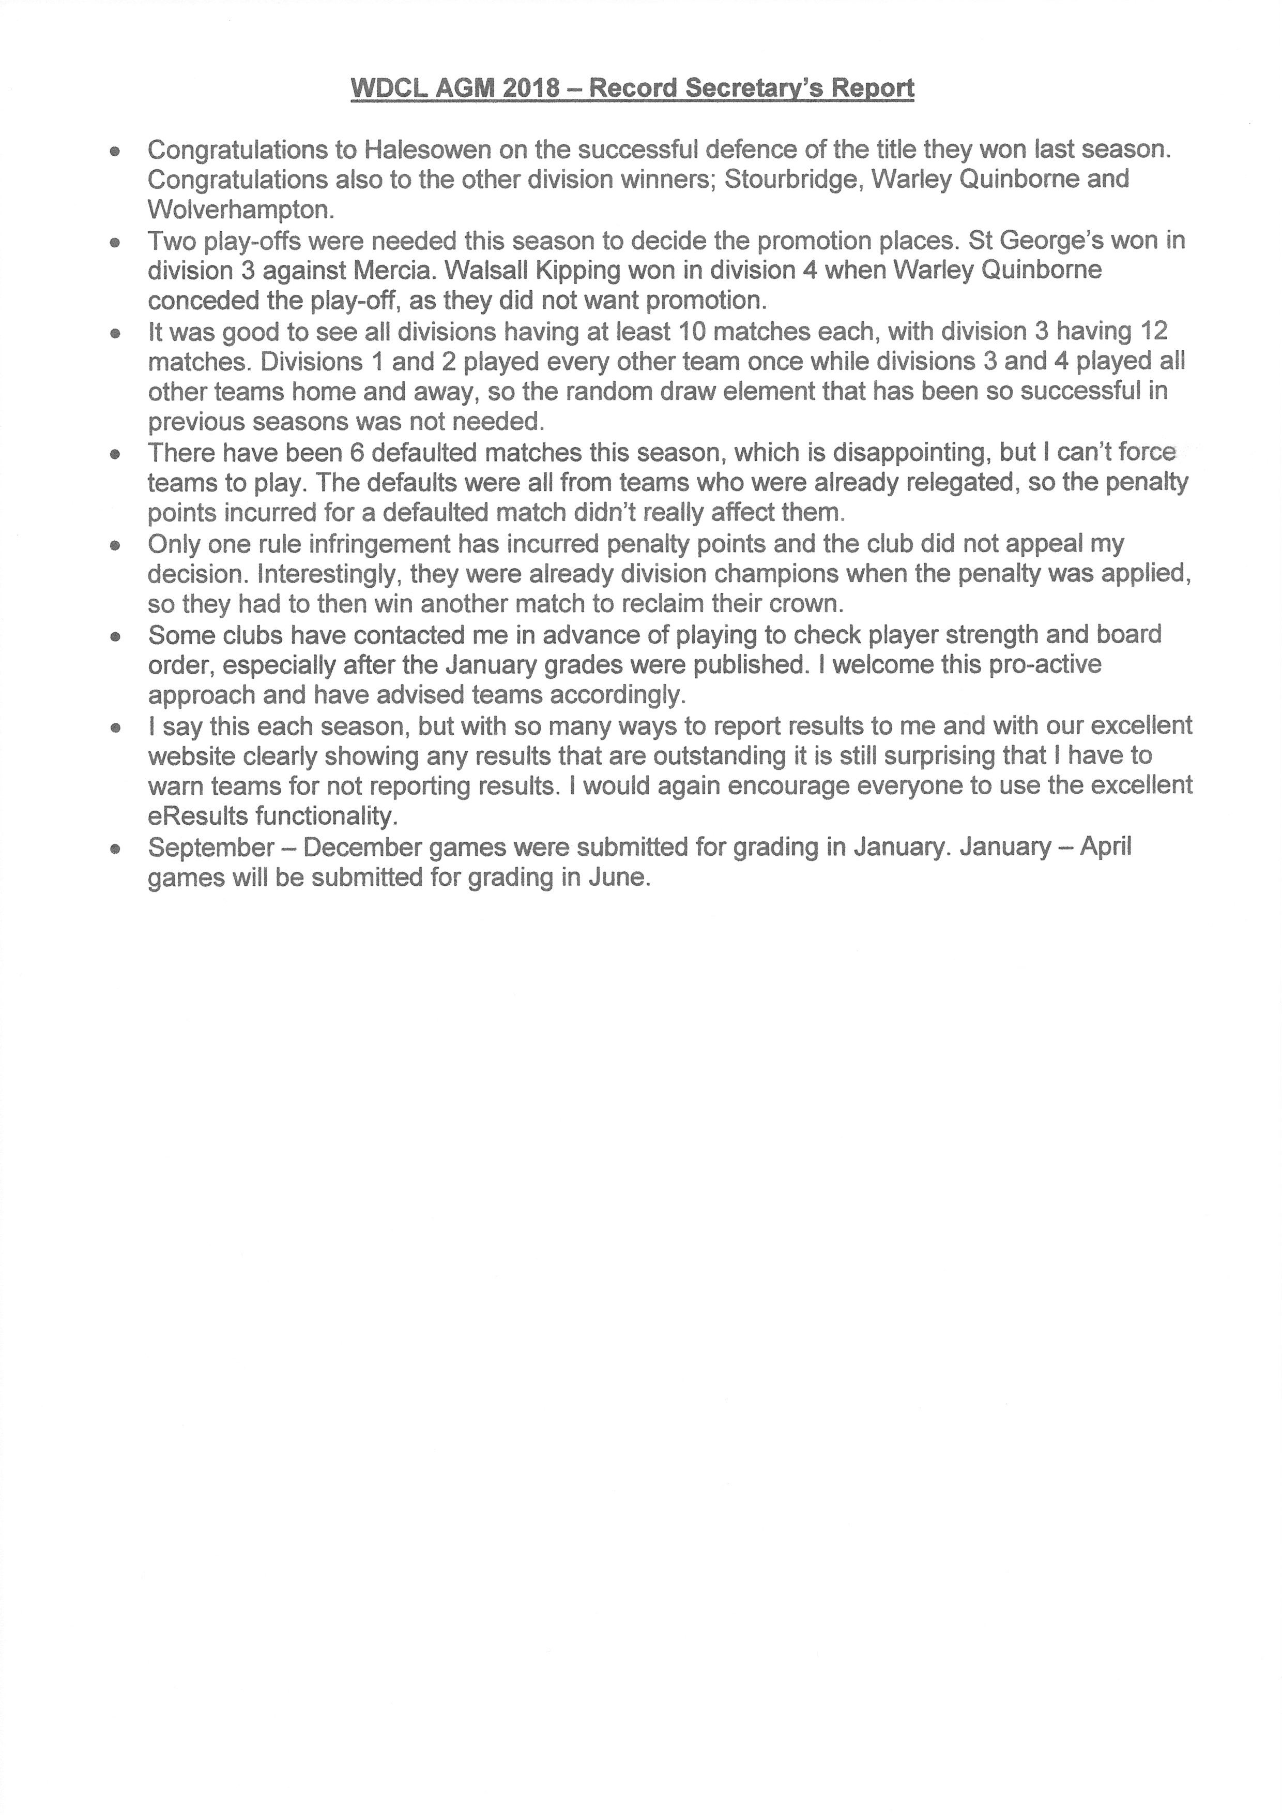
- Tounament Secretary’s Report: DP
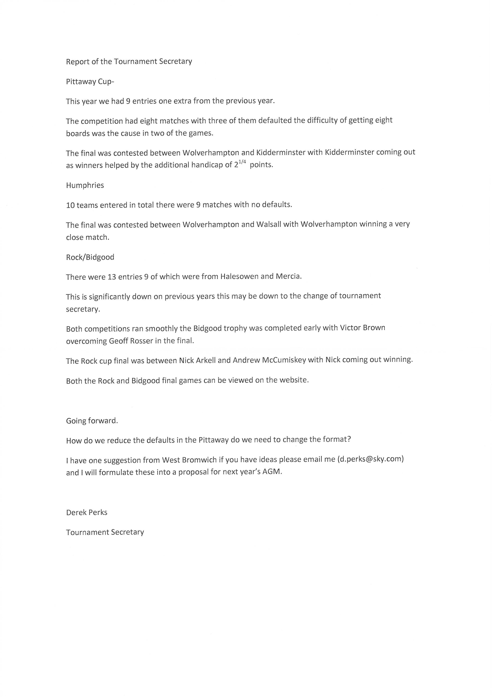
- Safeguarding Report: CH
There have been no reported issues in the season.
Clubs were asked to let Cath Hiley know the name of their Safeguarding Officer.
- Publicity Consultants Report: DS
Nothing to Report
- WebMaster Report: AM
The Webmaster was congratulated for maintaining a first class website
Webmaster Report 2018 Here is a summary of the work carried out since the last AGM.
- Addition of Obituary pages. If you spot any errors or omissions then please contact me.
- Addition of 1994/95 and 1989/90 to the archive. 12 previous seasons (not including this one now on-line). For 1994/95 the late rounds of the Rock/Bidgood and Pittaway were sadly not reported. If you have any knowledge of the missing matches then please contact me.
- Various small bugs, performance improvements and endless security updates
Appeals (as every year!!):
- We need more scoresheets and/or interesting positions for the web. (These can be
submitted anonymously if requested).
- We are still missing many WDCL Bulletins particularly 1985-86, 1990-91, 1993-94
and 1995-96. If anyone has any then we can scan them and return the originals if requested.
Site usage reveals a slight drop (-6.2%) in the number of users and a similar number of session. However, the session duration increased meaning those who do visit stay longer.
On the defaults, there was a considerable jump. Up to 88 boards (from 1,106 = 8%) defaulted compared with last year’s 40 (from 970 = 4.2%).
This years’ Top40 winners were:
Overall: Alex Jarvis (Rushall) our first junior to take the honour
Runner-up: Jon Pincher (West Brom)
Best White: Pauline Woodward (Warley Q)
Best Black: John Fryer (Lichfield)
Female/Junior: Amrissa Johal (Wals Kipp) with Alex Javis 2nd
New Data Protection Law
Finally, as some of you are aware on 25th May 2018 there are new EU laws coming into affect regarding data protection. These control the usage of personal data such as Names, Addresses, eMails, Tele numbers, photos as well as the analytical data we collect via Google. So there will be various changes for next season. For exmaple, the eResults registration will NOT be done automatically in Sept. ALL Captain’s will have to re-register via the registration button each season. This will provide a template eMail consenting the WDCL to use your name and eMail for the coming season. Silence, pre-ticked boxes and inactivity will no longer suffice as consent. eResults eMails are already sent out bcc. We will have a new ‘Privacy Notice’ which you will be directed to at various places on the website and also on eResults eMails. If you have a query regarding the changes or would like to know what we hold against your name then please contact me. Here is the link from the ECF giving advice for leagues and clubs. Link: https://www.englishchess.org.uk/wp-content/uploads/2018/04/GDPR-County-and- Club-Guide.pdf
- ECF Representative Report: AL
Report of Financial Council Mtg
Members Subs will be the same as last year, but there will be no £1 discount. ECF want individuals to register and pay.
Some clubs have players who have exceeded the 3 game free period and have not yet paid ECF fees. Clubs will be fined when this happens (£16 the bronze membership fee).
Change for juniors, will now be £5 with first year free.
The proposal to merge silver and bronze membership was not accepted.
Proposals to change county matches defeated.
The number of votes the WDCL gets depends on the number of games they submit for grading. If clubs submit internal tournament games (played under the rules) through the league they will maximise the votes the league gets.
Questions: Why ECF have the discounts gone?
Answer: ECF have changed the company they use to collect money and the 3 year membership period has finished and will not be renewed. This is the time to start a new policy.
- Prize Distribution: DP/MC
The President Matthew Carr presented trophies to all the competition winners.
Photographs were taken.
- Elections
Officers:
President (M Carr) and Deputy President (M Groombridge) are half way through their terms and will remain in office for one more year.
The other officers were elected in turn.
Secretary: David Fone
Treasurer: Paul Sharratt
Records Secretary: Dave Scriven
Tournament Secretary: Derek Perks
Publicity Consultant: David Short
Lead for Safeguarding: Cath Hiley
Other Officials: all elected
ECF Rep: Andrew Leadbetter
Rules Committee members: Andrew Leadbetter, Richard Thompson, Frank Wood
- Appointments:
Webmaster: Andrew McCumiskey
Auditor: Derek Perks.
- League Team Applications:
Clubs presented their preferences for teams for next season for league and cup competitions.
Following the meeting the Records secretary has completed the composition of the leagues and cup entries and circulated all the clubs wuth the league structure for next season.
- Proposals:
Proposal(i)
The current Rule 13 should be changed to the following for all games in all competitions in WDCL
13. Use of clocks
The use of clocks shall be compulsory, and the time limits shall be one of the following options the default rate of play will be option (1):
(1):All moves in 80 minutes with 10 seconds per move added throughout (incremental) if sufficient digital clocks are available.
(2) All moves in 90 minutes
This will mean that rules 8 Adjournments and 9 Adjudications will be no longer needed and rules for play-off matches and cup matches will follow the new rule if adopted.
After discussion an alternative proposal was made from the floor that the default option be
All moves in 75mins with 10 sec per move added throughout.
The pros of this where that it would shorten the total playing time and allow those with for longer travel to get away earlier.
The cons were that it would create a different time limit to that adopted by BDCL. As many clubs play in both leagues they favoured standardising the time to the original proposal.
The alternative was proposed by A Leadbetter and seconded by P Evans. The vote was 3 in favour and 11 against.
Next the vote was taken on adopting the new proposal as put forward in the agenda.
The committee had proposed this change and it was 2nd by David Blower.
This was approved by 16 votes for and none against.
The new rule 13 was adopted and will be used with effect from the start of next season.
Proposal (ii)
The WDCL adopt the following Privacy policy
Wolverhampton and District Chess League
Data Protection Policy May 2018

Wolverhampton and District Chess League (WDCL) organises competitive chess matches between member clubs and individuals through a programme of fixtures between teams and individuals in league and cup matches.
In order to organise this programme WDCL will ask member clubs annually to provide the following information:
- Its name, address of club venue and day and time of club meetings. (The club details)
- The name, telephone number and email address of the people through which it can be contacted, usually the secretary and team captains. (The clubs contact information).
- The names, and ECF details of its members for the purpose of registering them to play in WDCL competitions.
WDCL will only use this information to:
- Publish a handbook annually with the club details and their contact information.
- Maintain a web site with the club details and their contact information
- Publish league tables on the web site.
- Publish match results with individual’s names and chess grades on the web site
- Communicate results of individual games to the ECF for grading.
- Publish games that individuals have sent for publication.
- Provide statistical analysis of games played and performance records of players.
- The club details and contact information in the Handbook and on the webpage will be updated annually.
The information provided to WDCL will be held by its officers on their computers and on the web page as detailed above.
Except as detailed above information will not be provided to third parties.
WDCL will use forms to collect the information for the Handbook, web page and registration of players. The form will include the authorisation to use the information as detailed above.
Information on the web page will only be entered by registered users, using a registration process.
All queries regarding the Data Protection should be directed to the WDCL General Secretary.
This policy will be displayed on the webpage.

The need for the policy was explained. The adoption of the policy was proposed by Frank Wood and 2nd by Barry Smith. The policy was adopted 16 votes for and none against, the Data Protection / Privacy Policy was adopted.

- AOB:
Date of fixtures mtg confirmed as June 14th at Wolverhampton Club
Date of next years AGM to be week before Spring Bank Holiday on 22nd or 23rd May
P Evans pointed out that 2020 is the 75th anniversary of the league. The committee will consider running celebration event(s). A junior tournament for local schools and club junior teams was suggested. A lightning tournament was also suggested.
Other ideas welcome.
- The meeting finished at 20h50

