Wolverhampton and District Chess League
Minutes of AGM 23rd May 2019 at Wolverhampton Chess Club @ 7h30pm

- Apologies: Dave Davies, Ken Wise, Frank Wood, John Fryer
Attending: Matt Carr (President), David Fone (Gen Sec), Dave Scriven (Records Sec, Stourbridge), Mike Groombridge (Dept President, Walsall Kipping), Malcolm Phipps (Oscott, ex Boldmere), David Short (Publicity Officer, Lichfield), Paul Sharratt (Treasurer,Stourbridge), Steve Wilcox (Rushall), Michael Oakes (Wolverhampton), Pete Banks (Halesowen), Nat Paul (Telford), Richard Thompson (Telford), A. Ansari (Telford), I. Jameson (Telford), C Lewis (Telford), Barry Smith (Mercia), David Blower (Brewood), Peter Nixon (Walsall Kipping), John Whitehead (Bushbury), Cath Hiley (Lead for Safeguarding, Rugeley), Andrew McCumiskey (Webmaster, Mercia), Dave Close (Kidderminster), Pete Evans (Stafford), Andrew Leadbetter (ECF Rep, Stafford),
24 members, 14 clubs, 3 clubs not represented.
- Minutes of 2018 AGM Approved and signed by the President.
- No Matters Arising from 2018 AGM
- General Secretary’s Report
Sadly, we lost Derek Perks our Tournament Secretary and Auditor in October 2018. He will be greatly missed. His obituary is on our excellent website. The role of Tournament Secretary was split between Dave Scriven and me. The team competitions have been run by Dave Scriven and I ran the individual competitions. Reports to follow.
John Fryer (Lichfield Treasurer) has offered himself for adoption as our new Auditor.
We currently have no nominations for Tournament Secretary. We need someone to step forward to run these competitions, both because Dave and I do not want to take this on permanently and because we need to get new blood onto our committee.
We’ve had three clubs change venues this season (one changed twice). Some clubs have found it difficult to get suitable venues. There have been some unfortunate instances where the level of background noise in a venue has made it difficult to play chess. We’ve also had two clubs change their secretary during the season. The website has been kept up to date and I’ve circulated information to club secretaries.
The committee have started to discuss special events for our 75th anniversary in 2020. Thanks to Matt Carr for running a successful Blitz Tournament on May 2nd (results on the web) and thanks to Wolverhampton Club for hosting the event, and all our meetings.
As well as needing a new Tournament Secretary we also need a nomination for Deputy President, we need to get new blood on the committee so please consider coming forward. This is not an arduous task, with only one meeting a year normally.
Overall the season has run smoothly with no rule disputes.
My thanks to the rest of the committee for their support, and I am prepared to stand for nomination again for next season
David Fone General Secretary
- Treasurers’ report
Due to the illness and death of Derek Perks the accounts had not been audited for two years. John Fryer has agreed to correct this if appointed by the AGM. The rebates to clubs to reduce the WDCL reserves, agreed in 2017, will be completed this season, see below.
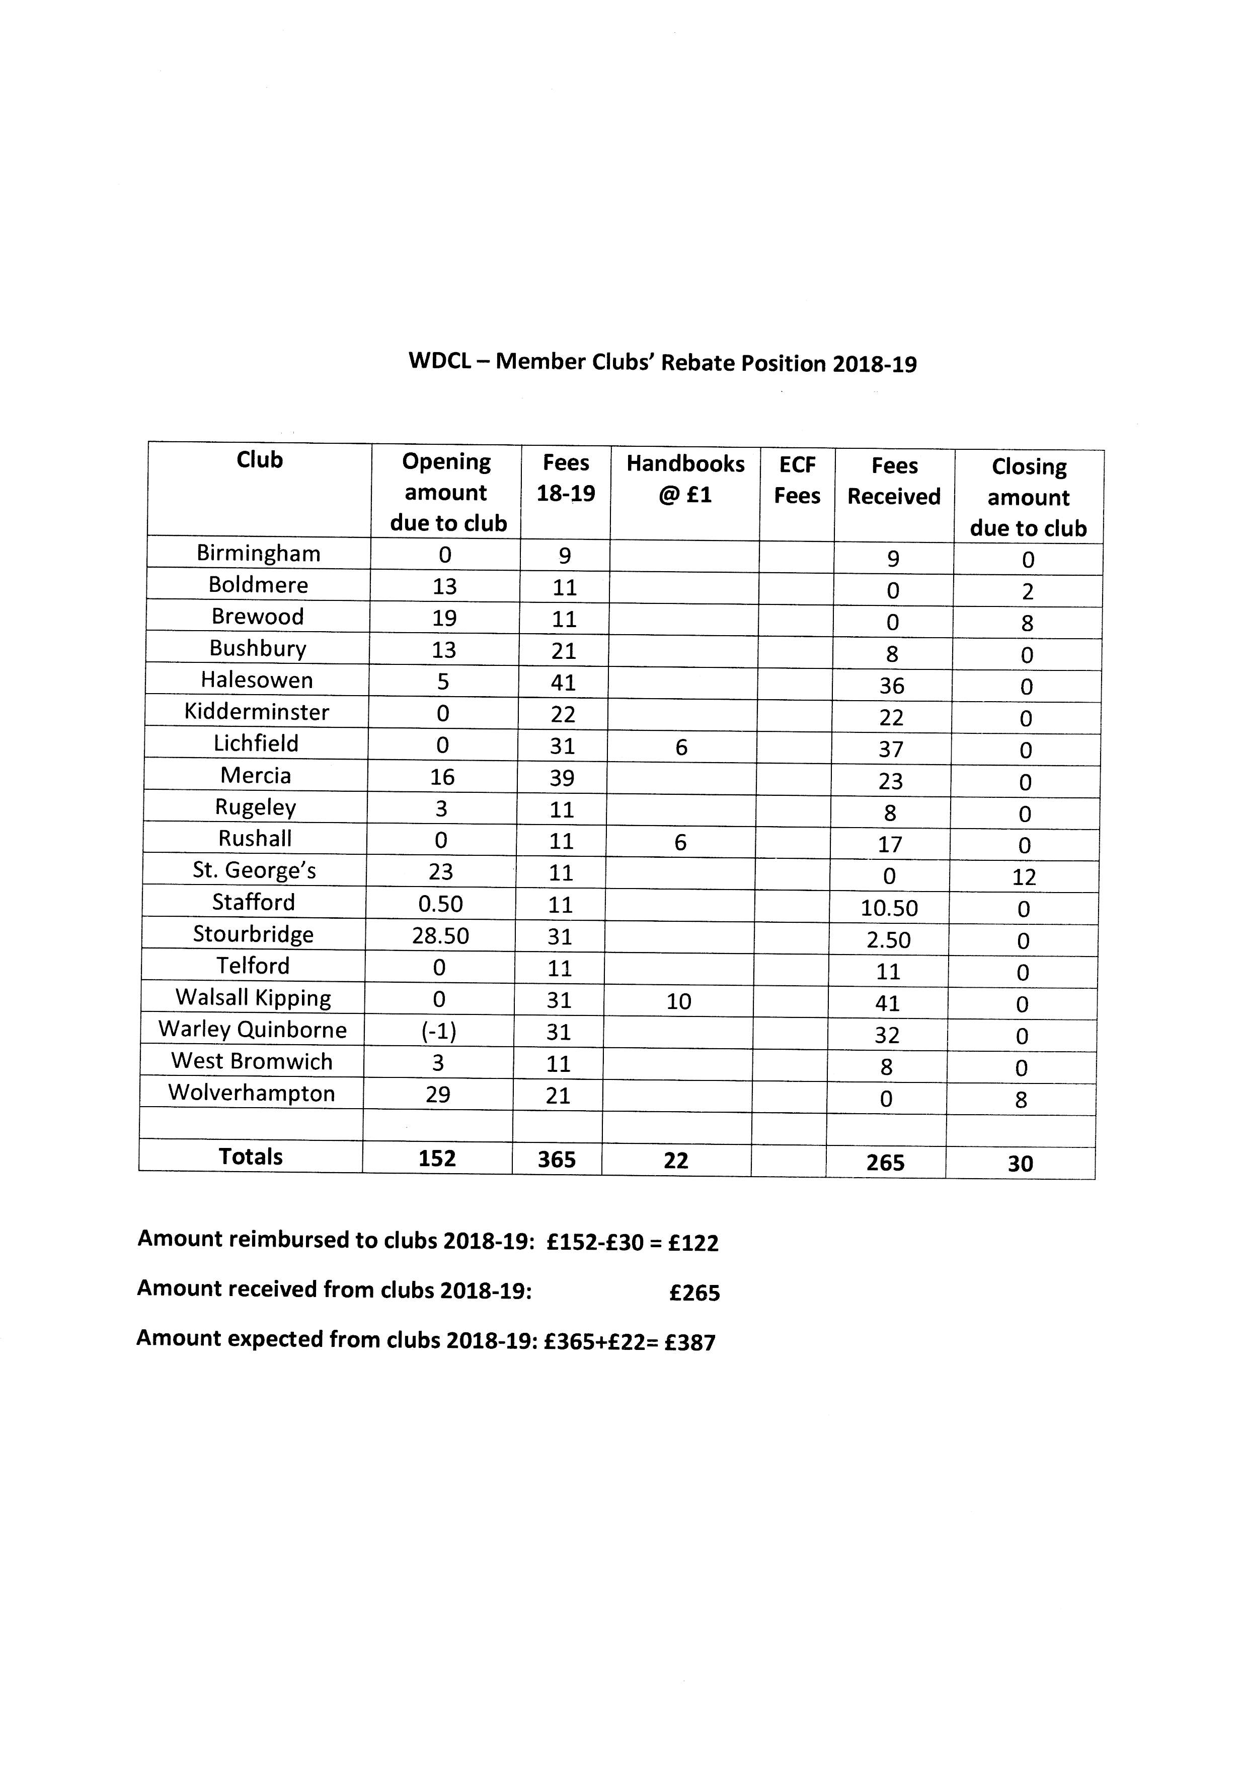
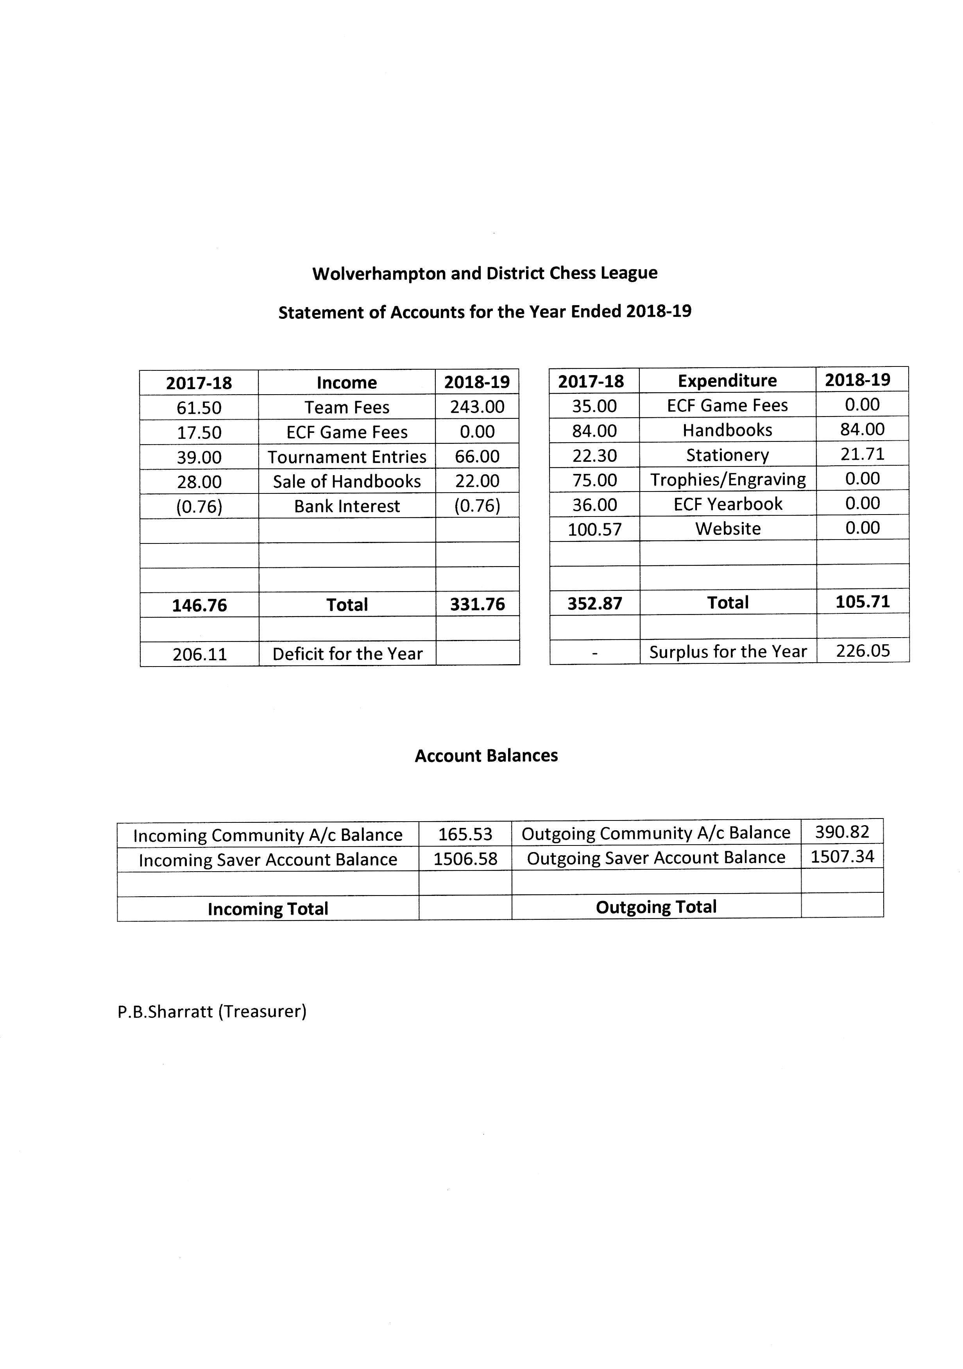

The accounts for 2018-19 shows the website cost £100.57, this is in fact the fee for 2 years as both payments fell in the same accounting year.
With the accounts showing a surplus the treasurer recommended that the league fees remain the same as last year. This recommendation was unanimously approved by the meeting.
- Records Secretary’s Report -Dave Scriven
WDCL AGM 2019 – Record Secretary’s Report

- This season a play-off was needed to determine the league champions. Telford won the play-off 3½ - 2½ against Walsall Kipping, who had been unbeaten all season with five wins and five draws. Congratulations to Telford. Congratulations also to the other division winners; Mercia, who needed a play-off against Boldmere to win division 2, Wolverhampton division 3 and Mercia division 4.

- It was a shame Mercia withdrew their “D” team early in the season, but at least all teams in all divisions still had 10 matches.

- There have been 7 defaulted matches this season, which is disappointing, but I can’t force teams to play. Equally disappointing is the fact one team never once managed to field a complete team. Hopefully next season will be different.

- There have not been any rule infringements this season, so the only penalty points I have imposed are for defaulted matches.

- I have to say there has been a lot of creativity this season: creative board orders, creative scheduling of fixtures, creative estimating of ungraded players’ playing strength, creative player registrations. I’m not saying any rules have been broken, because they haven’t, but I have heard some people suggest the creativity may have gone too far and have suggested additional rules may be needed. At present I don’t feel there is a need for any new rules.

- I have had correspondence with more than one team regarding the rules or my interpretation of them. Whilst the teams may not have necessarily agreed with me, none have raised disputes against the Record Secretary. If anyone has got questions about the rules throughout the season, please feel free to ask me. I know one team did ask in advance and therefore avoided causing an infringement.

- Similar to rule enquiries, some clubs have contacted me in advance of playing to check player strength and board order, especially after the January grades were published. I welcome this pro-active approach and have advised teams accordingly.

- I say this each season, but with so many ways to report results to me and with our excellent website clearly showing any results that are outstanding it is still surprising that I have to warn teams for not reporting results. I would again encourage everyone to use the excellent eResults functionality. Actually, using the e-results makes my role easier, but I will continue to receive results via other methods.

- September – December games were submitted for grading in January. January – April games will be submitted for grading in June.
- Tournament Secretaries Reports
WDCL AGM 2019 – Tournament Secretary’s (Team) Report- Dave Scriven

- Only 7 teams entered the Pittaway Cup, which was slightly disappointing and was two less than the previous season.
- On the plus side, no matches were defaulted which is always good to see, whereas two matches were defaulted last season, including a semi-final.
- Mercia reached their third Pittaway final in five years, but had never won the trophy.
- Stourbridge last appeared in the final in 2010, and hadn’t won the trophy since 1977.
- In the final Mercia not only had a 2¼ point handicap advantage but also outgraded Stourbridge on the top five boards.
- I still don’t know how Stourbridge managed to win! They scored the required 5½ across the eight boards to win 5½ - 4¾.

- 8 teams entered the Humphreys Cup, which was two less than last season, but at least made the draw very simple.
- No matches were defaulted, which is always good to see.
- The final was between two teams who between them had won the Humphreys Cup for the last four years:
  - Stourbridge had won in 2015, 2016 and 2017
  - Wolverhampton had won in 2018.
This year it was Wolverhampton who managed to repeat their success from last season with a 3-1 victory.
WDCL Tournament Secretary’s Report (Individual Competitions) -David Fone

Following the sad loss of Derek Perks out Tournament Secretary in October 2018, Dave Scriven and I split the role between us to keep the tournaments running for the 2018-19 season. Dave Scriven took the team competitions and I ran the individual competitions, the Rock Cup and Bidgood Trophy.
We had a near record 22 entries. As usual the first round was seeded so that the strongest players did not play each other in the first round. The eleven first round winners continued in the Rock Cup and the first round losers in the Bidgood Trophy.
Both competitions were completed by early May with the Rock Cup being shared between current holder Nick Arkell (Halesowen) and Lee Grinsell (Bushbury).
The Bidgood Trophy was retained by rising star Vic Brown after beating Mike Groombridge in an all Walsall Kipping final.

We desperately need someone to come forward and take over the Tournament Secretary role for next season, I do not wish to continue with this role.

David Fone General Secretary May 2019
- Safeguarding Report -Cath Hiley
Nothing to report.
The WDCL Safeguarding policy was adopted again by the AGM.
- Publicity Officer’s Report - David Short
David outlined his planning for a special event for the WDCL 75th anniversary in 2020. A special match between Wolverhampton and Walsall Kipping is been suggested, to recreate the atmosphere and dress of 1945. Details to follow.
The event will be used to attract publicity for the league.
- WebMaster’s Report – Andrew McCumiskey
Webmaster Report 2019 Here is a summary of the work carried out since the last AGM.
- Standardisation of pages to HTML5. This should give a more consistent feel to the site.
- Upgrade of database to give much better performance.
- Addition of the ‘Shock results’ to the Stats section.
- Various small bugs, performance improvements and endless security updates
Player registration on eResults for Captains
To comply with Data protection we did not copy the previous logins from the previous season to the new season. This meant that all Captain’s had to re-register and most only did this after they played their first game! This meant a lot of extra work and stress. This year I will go back to copying the previous registrations unless you object to this on your player registration forms.
Appeals (as every year!!):
- We need more scoresheets and/or interesting positions for the web. (These can be
submitted anonymously if requested).
- We are still missing many WDCL Bulletins particularly 1985-86, 1990-91, 1993-94
and 1995-96. If anyone has any then we can scan them and return the originals if requested.
Considerable site usage increase in both the number of users (4,400) and a similar number of sessions (22,000). Mobiles are now 33% of views and most popular viewing times are Thu and Fri lunchtimes. See below for stats.
On the defaults, slightly down to 83 boards (out of 1,099 = 7.6%) defaulted compared with last year’s 88 (8%).
This years Top40 winners were:
Best Overall: Andrew Leadbetter (Stafford)
Runner Up: Mark Keady (Brewood)
Best White: Christopher Bellin (Walsall Kipping)
Best Black: Mark Keady (Brewood)
Best Junior/Female: Silas Bowcott-Terry & Sandu Manvith runner-up (both Halesowen) Andrew McCumiskey (WDCL Webmaster)
Andrew also asked the meeting if WDCL would like to create a social media page to attract more junior members. Action The secretary was asked to check with WDCL Clubs.
Andrew also told the meeting about a project he is developing to provide clubs with their own web sites, this work is independent of his role as WDCL webmaster and not connected to the WDCL.
- ECF Report – Andrew Leadbetter
Andrew reported that Staffordshire County have three teams u140, u120 and u100.
The ECF are looking at moving to monthly grading and using a four figure grade, but not before Aug 2020.
ECF fees are going up from Sept 2019, details on the ECF webpage.
MCCU organised a Junior congress, which was not well attended.
There is a free silver membership for one year available to juniors to enable them to enter congresses.
- Presentation of Trophies
Matt Carr presented the trophies
WDCL AGM May 23rd 2019
Presentation of Trophies
Bidgood Trophy Runner up | Mike Groombridge
Bidgood Trophy Winner | Vic Brown
Rock Cup Winners | Nick Arkell and Lee Grinsell
Blitz Tournament | West Bromwich
Humphreys Trophy | Wolverhampton
Pittaway Cup | Stourbridge
Div 4 Champions | Mercia C
Div 3 Champions | Wolverhampton B
Div 2 Champions | Mercia A
Div 1 Champions | Telford
- Election of Officers
The Following officers were elected unopposed
President: Mike Groombridge
Deputy President: Malcolm Phipps
Gen Secretary: David Fone
Treasurer: Paul Sharratt
Records Secretary: Dave Scriven
Tournament Secretary: Matt Carr
Publicity Officer: David Short
Lead Safeguarding: Cath Hiley
Other Officials:
ECF Representative: Andrew Leadbetter
Three ex officio members for the Rules Committee:
Andrew Leadbetter, Richard Thompson and Frank Wood.
- Appointments
Auditor: Jon Fryer
Webmaster: Andrew McCumiskey
- Teams for 2019-2020
Clubs present gave their teams for the league and cup competitions to the records secretary. Clubs not present will have to be chased by the records secretary.
- Proposals
Currently the Eligibility Rule for entry into the Bidgood Trophy refers to Staffs County first team, which is no longer run.
The rule states
ELIGIBILITY
The Rock Cup is an individual knock-out tournament, open to all registered members of clubs playing in the WDCL, for the individual championship. Everyone, with the exceptions listed below, plays at least two games, as Round 1 of the Rock Cup will be seeded, and first round losers are automatically entered for the Harold Bidgood Trophy. Winners will hold the Cup or Trophy for one year. In future, both winners and runners-up will also receive appropriate trophies to keep, rather than cash prizes. The entry fee is £3 per player and cheques and postal orders should be made payable to the Wolverhampton & District Chess League. Closing date for entries is the 30th September. Results will be published on the internet at WDCL. The following players will not be eligible to compete in the Harold Bidgood Trophy: A) Any player who, during the previous season, played on one of the top ten boards in a County (1st team) match B) Any player defaulting in the first round of the Rock Cup
The meeting debated how to limit entry into the Bidgood Trophy to the weaker players in the Rock Cup entry and agreed the following rule
The Rock Cup is an individual knock-out tournament, open to all registered members of clubs playing in the WDCL, for the individual championship. Everyone, with the exceptions listed below, plays at least two games, as Round 1 of the Rock Cup will be seeded so the highest graded entrants do not play each other, and first round losers are automatically entered for the Harold Bidgood Trophy. Winners will hold the Cup or Trophy for one year. In future, both winners and runners-up will also receive appropriate trophies to keep, rather than cash prizes. The entry fee is £3 per player and cheques and postal orders should be made payable to the Wolverhampton & District Chess League. Closing date for entries is the 30th September. Results will be published on the internet at WDCL.
The following Players will not be eligible for entry into the Harold Bidgood Trophy
a) Any player defaulting in the first round of the Rock Cup.
b) At the discretion of the Tournament Sec the top X players in the Rock Cup entry will be excluded from the Bidgood Trophy if they lose their first round game. X will be set by the Tournament Controller when players are known.

- The fixtures Meeting was fixed for June 27th at Wolverhampton Chess Club.
Brewood have moved venue new info on WDCL webpage
Kidderminster will play on Monday, info to be confirmed in new handbook.
- The meeting closed at 21h15

