Minutes of WDCL AGM May 21st 2024 at the Crown Inn, Sedgley

- President David Hodkinson took the chair and welcomed everyone.
He reported the season had been trouble free. He asked for a pause to remember Gordon Sands who was a Mercia member and a keen chess player who died in February 2024.
- Apologies
Chris Lewis, Deputy President and Richard Thompson (Telford).
Attending: David Hodkinson (President, Mercia), David Fone (Gen Secretary, Lichfield), John Fryer (Treasurer, Lichfield), Phil Maybury (Warley Quinborne), Phil Bull (Wolverhampton), Adam Routledge (Lichfield), Andrew McCumiskey (Mercia, Webmaster), George McCumiskey (Mercia), Michael Share (Mercia, Auditor), Will Vout (Mercia, Tournament Secretary), John Lunn (St Georges), Paul Sharratt (Stourbridge, Records Secretary and ECF Rep), Steve Wilcox (Rushall), Catherine Hiley (Rugeley, Lead for Safeguarding), Dan Turner ( Rugeley), David Waud ( Kidderminster), David Davies (West Bromwich), Ken McNulty (Stafford), Peter Evans (Stafford), Stewart Fishburne (Halesowen), Roger Brown (Telford), Mike Biddle (Oscott), Barry Smith (Mercia), Mike Groombridge (Walsall Kipping), David Cooper (Halesowen). Total 26
Bushbury were the only club not in attendance.
- Minutes of the 2023 AGM
The president asked the meeting for approval of the minutes of the 2023 AGM. The meeting approved them nem. con.
- There were no matters arising from the minutes of the last AGM.
- Officers Reports:
President: David Hodkinson reported on the success of the league in 2023-24 and congratulated Halesowen as League Champions.
He thanked everyone for their support during his two years in office and encouraged others to come forward as the role did not entail a lot of time.
The meeting thanked David for his time as President.
General Secretary: David Fone reported 2023-24 has been a trouble free season, things have gone relatively smoothly with no disputes, so no need for the rule committee to meet.
My thanks go to the other officials of the league, especially this year to Will Vout for taking on the job of Tournament Secretary successfully. As usual without Paul Sharratt sorting fixtures and keeping records the league could not function. We also need to give a big vote of thanks to our webmaster Andrew McCumiskey for running a superb website that keeps us all up to date daily.
On a sombre note we need to remember Gordon Sands who passed away in February 2024 after playing in the WDCL for many years. A very keen player who we will all miss.
My job as secretary has not been demanding. We have held one committee meeting to prepare for the AGM. All the paperwork for the AGM was sent to clubs ahead of the deadlines written into the constitution. We are proposing some rule changes which we will vote on in the meeting.
My congratulations to Halesowen on bouncing back to win the league again, for a fourth time.
I hope you have all enjoyed your chess and enjoy the diversity of competition the WDCL offers to member clubs.
Records Secretary: Paul Sharratt thanked the club captains and secretaries for prompt reporting of results. The occasions where results are not reported are rare but very disruptive. This delays getting information to ECF and means player grades are not updated, to the frustration of the players involved.
Paul thanked Andrew McCumiskey for his support and excellent running of the website.
A question on defaults was addressed in the WebMasters report.
Tournament Secretary: Will Vout reported
The Humphreys Trophy was held at Mercia’s venue on the 17 October 2023 with 5 different clubs represented and a total of 7 teams following a late withdrawal. After 14 hard fought matches Mercia A and Lichfield were tied with equal points, identical board counts and the same elimination rule. Mercia A were victorious based on having black on Board1. Thanks to all teams and clubs who took part.
Recommendation for next year:
To propose changes to the black on board 1 rule which isn’t really suitable for a jamboree event.
The Pittaway Cup was held at Mercia’s venue on 30 April 2024 with teams entered by 4 clubs. This ran slightly more smoothly than the Humphreys with no withdrawals or defaults. Only 1.25 points separated all 4 teams with Mercia prevailing after benefitting from the handicap. Thanks to all teams and clubs who took part.
The Rock Cup started in October 2023 and continued until April 2024. There was an increase in the number of entries this year with 24 players starting the competition from 4 different clubs. During the competition we only had 1 default as a result of external commitments. The final was an all Mercia final contended by Andrew McCumiskey and Will Vout. Andrew prevailed in an open game and retained the Rock Cup. Thanks to all the players that entered the Rock Cup, I hope they had some enjoyable matches.
The Bidgood Trophy started in January 2024 and continued until April 2024. There were 12 entries from the Rock Cup. For various reasons 3 players were unable to complete their fixtures resulting in a number of byes. The final was contested by Phil Maybury of Warley Quinborne and Chris Bateson of Mercia with Phil prevailing and retaining the Bidgood Trophy. Thanks to all the players that entered the Bidgood Trophy, I hope they had some enjoyable matches.
Treasurer: John Fryer reported: Income is team fees plus a little bank interest. There were no Cup entry fees last year.
The new AGM venue should mean no rent to accrue for this year and with just engraving to do with no prizes etc. these costs are £93 (2023 £169). Website costs were accrued the previous year and covered a two year period to April and June 2025 so these won’t arise again for another 12 months. These reduced costs result in a surplus of £231 (2023 -£20). Bank balances are £1,887 (2023£1,868) and after accruals net assets are £1,794 (2023 £1,564).
If engraving costs remain at £100 for next season and no rent and no website hosting costs we don’t need an income of £300 to cover these so I am recommending a reduction of team fees to £5 per team next season. Our resources are sufficient to handle any extra engraving, prizes, expenses etc. In the following season we will incur web hosting costs again and team fees will then be reviewed.
The very few instances of club members at risk of game fees have been contacted, those members should renew before 31St May, also any member whose rolling ECF subscription ends then should renew before 30th June, the ECF deadline.
The Tournament Sec said that the trophies may need modifying next year and that could cost £40.
A vote of thanks was given to auditor Michael Share.
The meeting voted on approving the Treasurers Report and reducing the team fees to £5 per team for next season. This was approved nem. con.
Safeguarding: Catherine Hiley reported there had been no safeguarding issues reported in WDCL. She has issued a draft updated safeguarding policy to the WDCL management team. Paul Sharrett made two comments.
1. Vulnerable adults need to be included in the policy. Catherine is waiting for ECF guidelines on the definition of “vulnerable adults” before incorporating that into the draft policy and circulating to clubs.
2. ECF are likely to recommend that organisations have a Lead for Safeguarding and two Safeguarding Officers. This is a response to an ongoing case where a safeguarding officer is a suspect perpetrator.
ECF Report: Paul Sharratt said there was little to report. Peter Evans said there had been changes to membership classes and that Gold and Silver membership had been combined onto one class, called “Gold”. Bronze still existed. The same thing is happening at junior level.
Webmaster: Andrew McCumiskey reported
Here is a summary of the work carried out since the last AGM.
Major upgrade to PHP 8.1 of coding
Improvements to usage on mobile screens
Various small bugs, performance improvements and endless security updates. Plans for next season:
Fully automate grading file sending to be weekly (rather than monthly).
Testing in the grading Sandbox has started.
Appeals: We need more scoresheets and/or interesting positions for the web. (These can be submitted anonymously if requested).
On the playing stats:
2023/24 boards played 655 of which defaulted 33 giving 5.0%
2022/23 617 20 defaults 3.2%, 2021/22 302 10 defaults 3.3%, 2019/20 1092 83 defaults 7.6%.
This year’s Top40 winners were:
Overall: Emmet Clarke (Stafford)
Runner-up: Dale Jackson (Halesowen)
Best White: Emmet Clarke (Stafford) and Andrew Perry (Walsall Kipping) 100%
Best Black: Matthew Carr (Rugeley) 100%
Female/Junior: Muhammed Mehmood (Mercia)
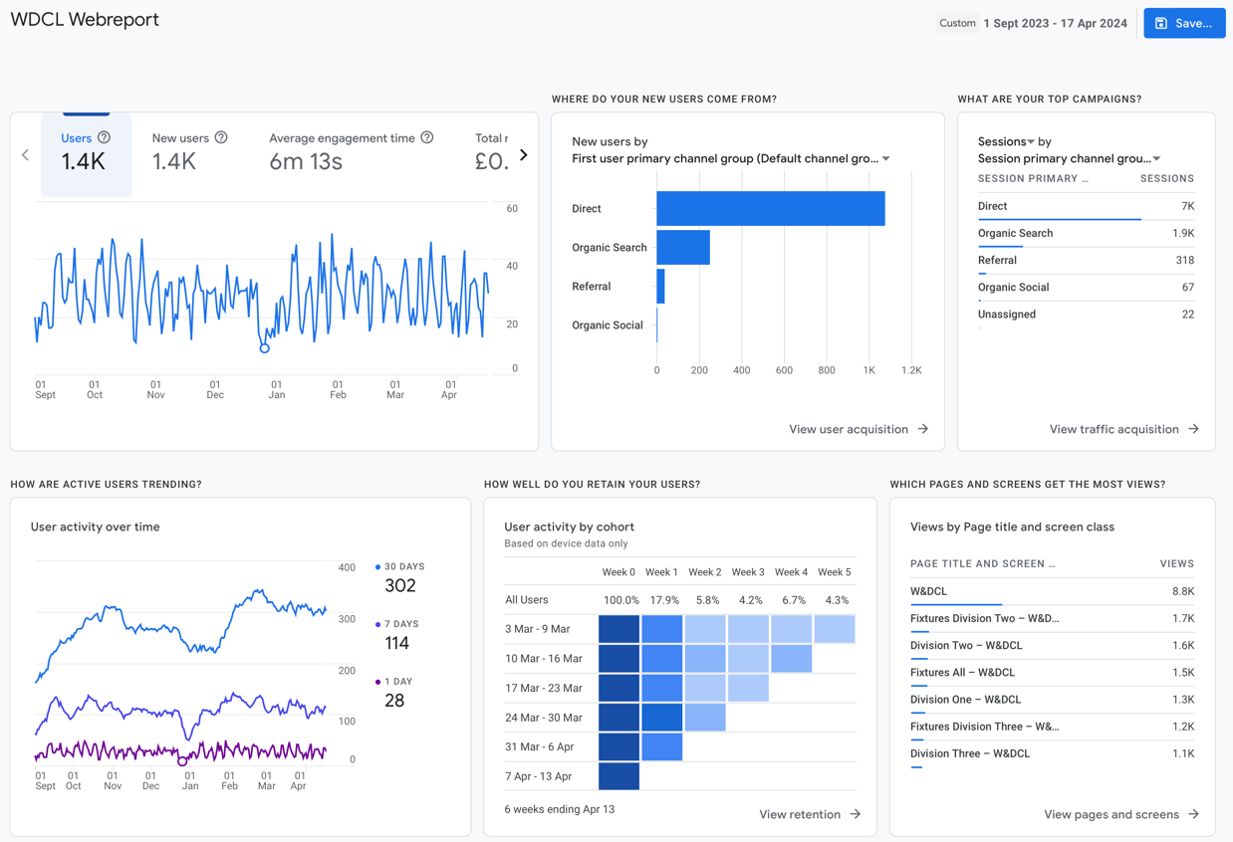

- Presentations:
President David Hodkinson presented the following Trophies assisted by Will Vout.
League Champions: Halesowen, received by David Cooper
Division 2 Champions: Mercia, received by Andrew McCumiskey
Division 3 Champions: Rugeley, received by Catherine Hiley
Humphreys Trophy: Mercia, received by Michael Share
Pittaway Cup: Mercia, received by Barry Smith
Rock Cup: Andrew McCumiskey (Mercia);Runner-up Will Vout (Mercia)
Bidgood Trophy: Phil Maybury (Warley Quinborne); Runner-up Chris Bateson (Mercia).
- Elections:
David Hodkinson (President) had completed his two year term and had to stand down. David Fone took the chair for the election of a new President.
Chris Lewis (Deputy President) was prepared to stand for President. The meeting was asked if there were any other nomination, and there were none. Paul Sharratt proposed Chris Lewis and John Fryer seconded. Chris was elected nem con. David Hodkinson received the thanks of the meeting for all he had done.
As Chris Lewis was not present David Hodkinson continued in the chair with the approval of the meeting.
Peter Evans was prepared to stand as Deputy President for two years. There being no other nominations, Ken McNulty proposed Peter and David Fone seconded. Peter was elected nem con.
Gen Secretary David Fone was prepared to stand again. There were no other nominations. David Waud proposed, and Peter Evans seconded. David Fone was elected nem con.
Treasurer John Fryer was prepared to stand again. There were no other nominations. David Fone proposed John and Paul Sharratt seconded. John Fryer was elected nem con.
Records Secretary Paul Sharratt was prepared to stand again. There were no other nominations. Mike Biddle proposed, and Barry Smith seconded. Paul Sharratt was elected nem con.
Lead for Safeguarding: Catherine Hiley was prepared to stand again. There were no other nominations. Paul Sharratt nominated and Will Vout seconded. Catherine was elected nem con.
Tournament Secretary Wll Vout was prepared to stand again. There were no other nominations. David Fone proposed, and John Fryer seconded. Will Vout was elected nem con.
The meeting also reappointed Andrew McCumiskey as Webmaster, Paul Sharratt as ECF Representative and Rules committee members Mike Biddle, Phil Bull and Andrew McCumiskey.
The meeting agreed the League constitution Committee should continue to be the President, Secretary and Records Secretary.
Michael Share was reappointed as auditor for 2024-25.

- Proposals:
1. Number of Boards per team in League Matches
With effect from season 2024-5 WDCL there will be six boards per team in Division One, five boards per team in Division 2 and four boards per team in any lower division.
This proposal follows the decision in Covid to reduce the number of boards to 4 per team on a year by year basis an allow each AGM to vote on whether or not to continue with 4 boards.
There was a wide ranging debate with the difficulties of smaller clubs fielding 5 or six board. Difficulties with transporting more than 4 players in one car on one side of the argument. In favour of six boards was that a club could have fewer teams and needed fewer captains, also that 6 boards is a more competitive team event.
The proposal was put to a vote with 12 votes for and 19 votes against. The proposal was rejected an WDCL will continue with 4 board teams in all divisions for 2024-25.
2. Tie Splitting for Jamboree Competitions.
If a Jamboree event finishes with teams tied on the same final score the team with the lowest total grading points (as agreed with the Tournament Secretary and recorded on the master match card before the start of the event) will be the winner.
The tie splitting rules currently are based on board count and board elimination, which only work when teams are playing head to head. In a Jamboree, players in the same team are playing opponents from any of the other teams in the competition. The use of gradings agreed before the start is a way of decisively splitting tied teams. The proposal was debated, and it was clarified that this would be to only tie splitting rule used in Jamboree events.
The proposal went to a vote and was adopted 18 votes for and 8 votes against.
3. Communications with Clubs
All member clubs are required to give the email address of at least two contacts to the league secretary at the start of each season and should respond to emails promptly to ensure the smooth running of the league.
The reason for the proposal is that a second point of contact with clubs is required by officers to ease the contacting of clubs to get vital information.
The proposal was adopted by28 votes for with none against.
4. Additional Start Time Option
Rule 6c be changed to read
c) Play in all match games must start at either 7.00pm, 7.15pm or 7.30 pm and each club must state in the league information sheet which they use for home matches. A continuous period of at least 3 hours must be allowed for the match.
(adds 7.00pm as an option for start time).
Some clubs must exit their club rooms by 10pm. To get a 3hr playing session that means starting at 7pm. The current rules do not allow a 7pm start time, but some exceptions have been made in 2023-24 for clubs whose venues have imposed a short term 10pm closer. The rule change was proposed to formalise the option of an earlier start time.
The proposal was debated.
Those clubs who must travel longer distances or have players who work late would not be able to make an earlier start time.
The proposal was defeated by 4 votes for to 22 votes against. We will continue with the current rule and allow league officials to make limited exceptions for clubs in exceptional circumstances.
If a club knew in advance that for a period, they would have to finish early they should avoid fixing home matches in that period.
- Team Entries for 2024-25.
Paul Sharratt took the team entries from each club and thought we could have 8 or nine teams in each of the 3 divisions. Based on these entries there would be no need for a relegation playoff from Division 1.
- AOB
Fixtures Meeting will be June24th at Wolverhampton club room starting at 7:30pm.
It was suggested we look at the tie splitting rule in the Divisions and consider amendment at the next AGM.
The meeting closed at 21:26pm

